Question 01 :

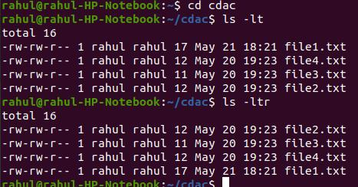

Question 02 :
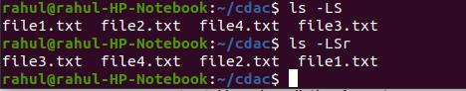

Question 03 :

rahul@rahul-HP-Notebook:~$/Documents/PERSONAL_DATA/OS/Assignment-01$ ls --inode
4985881 499955.jpg 5003023 naruto.jpg 5003025 sasuke.jpg
5003041 Assignment01.txt 5003024 natsu.png

OR

rahul@rahul-HP-Notebook:~$/Documents/PERSONAL_DATA/OS/Assignment-01$ ls -i
4985881 499955.jpg 5003023 naruto.jpg 5003025 sasuke.jpg
4988461 Assignment01.txt 5003024 natsu.png

Question 04 :

rahul@rahul-HP-Notebook:~$/Documents/PERSONAL_DATA/OS/Assignment-01$ ls -d */
Assignment_01/ Assignment_05/

Question 05 :

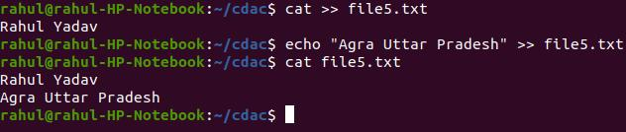

Question 06 :

Current Time Stamp :
ls -lt Slayer
-rw-rw-r-- 1 sunbeam sunbeam 41 May 20 18:29 Slayer

Changed Time Stamp :

touch -t 202005271430 Slayer

rahul@rahul-HP-Notebook:~$/Documents/PERSONAL_DATA/OS/ Assignment-01$ ls -lt Slayer
-rw-rw-r-- 1 sunbeam sunbeam 41 May 27 2020 Slayer

Question 07 :

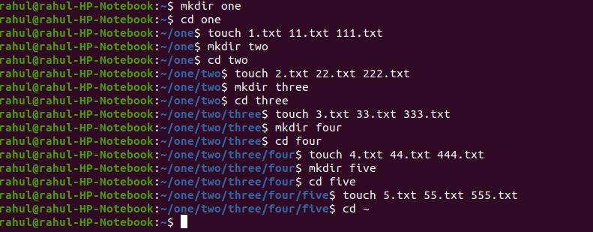

Question 08 :

a).

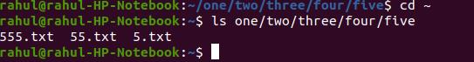

b).
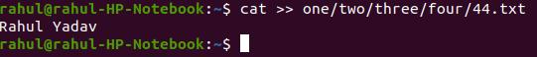
c).

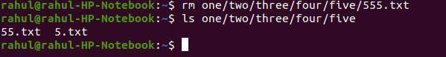

d).

e).
